Virtual Model Rocket Workshop Form

Dear Parents/Guardians and Participants,
Thank you for expressing interest in our model rocket-building workshop! The Spring Grove NASA Student Launch team is always pushing to provide STEM education activities for our community, and your interest is greatly appreciated.
In this workshop, your child will build a small model rocket kit free of charge, document their progress, and share photos or videos of building and completion with us. The model rocket can of course be flown at home if you have the materials (launchpad, motors, etc.), but if not, there will likely be a launch event held on campus this Spring. These kits can only be received for free if documentation is received. If you do not plan to document your building, then payment is required ($10/kit).
This workshop is being held by Spring Grove’s NASA Student Launch team. NASA SL is a program in which high school students build and fly a large high-power rocket, write professionally formatted documents detailing the rocket’s development process, and present their results to NASA representatives multiple times over an eight-month season. This model rocket workshop is just one of the many STEM engagement activities our team holds yearly.
To participate, fill out this form, return it to your student’s homeroom teacher, and complete the google form accessible via QR-code on the back of this sheet. All forms are due no later than Friday, February 19th. Once kits are received, payment or documentation of completion is due no later than Friday, February 26th. Contact information can also be found on the back of this sheet. The elementary schools will have 50 kits available each for 3rd and 4th grade students. Sign up soon.

Thanks again, the Spring Grove NASA SL Team

Student Name: ________________________________
Parent/Guardian Email: _________________________________
Student Signature: _________________________________
Parent/Guardian Signature: _________________________________
Even though this is a free activity if you complete the build and send in your photos, we accept donations for the NASA SLI team. Donations could be cash or check payable to SGASD with NASA SLI on the memo line.
You can follow our progress on Twitter at @sg_nasa_sl or on our website at www.springgroverocketry.weebly.com.
Google Forms Participation Sheet
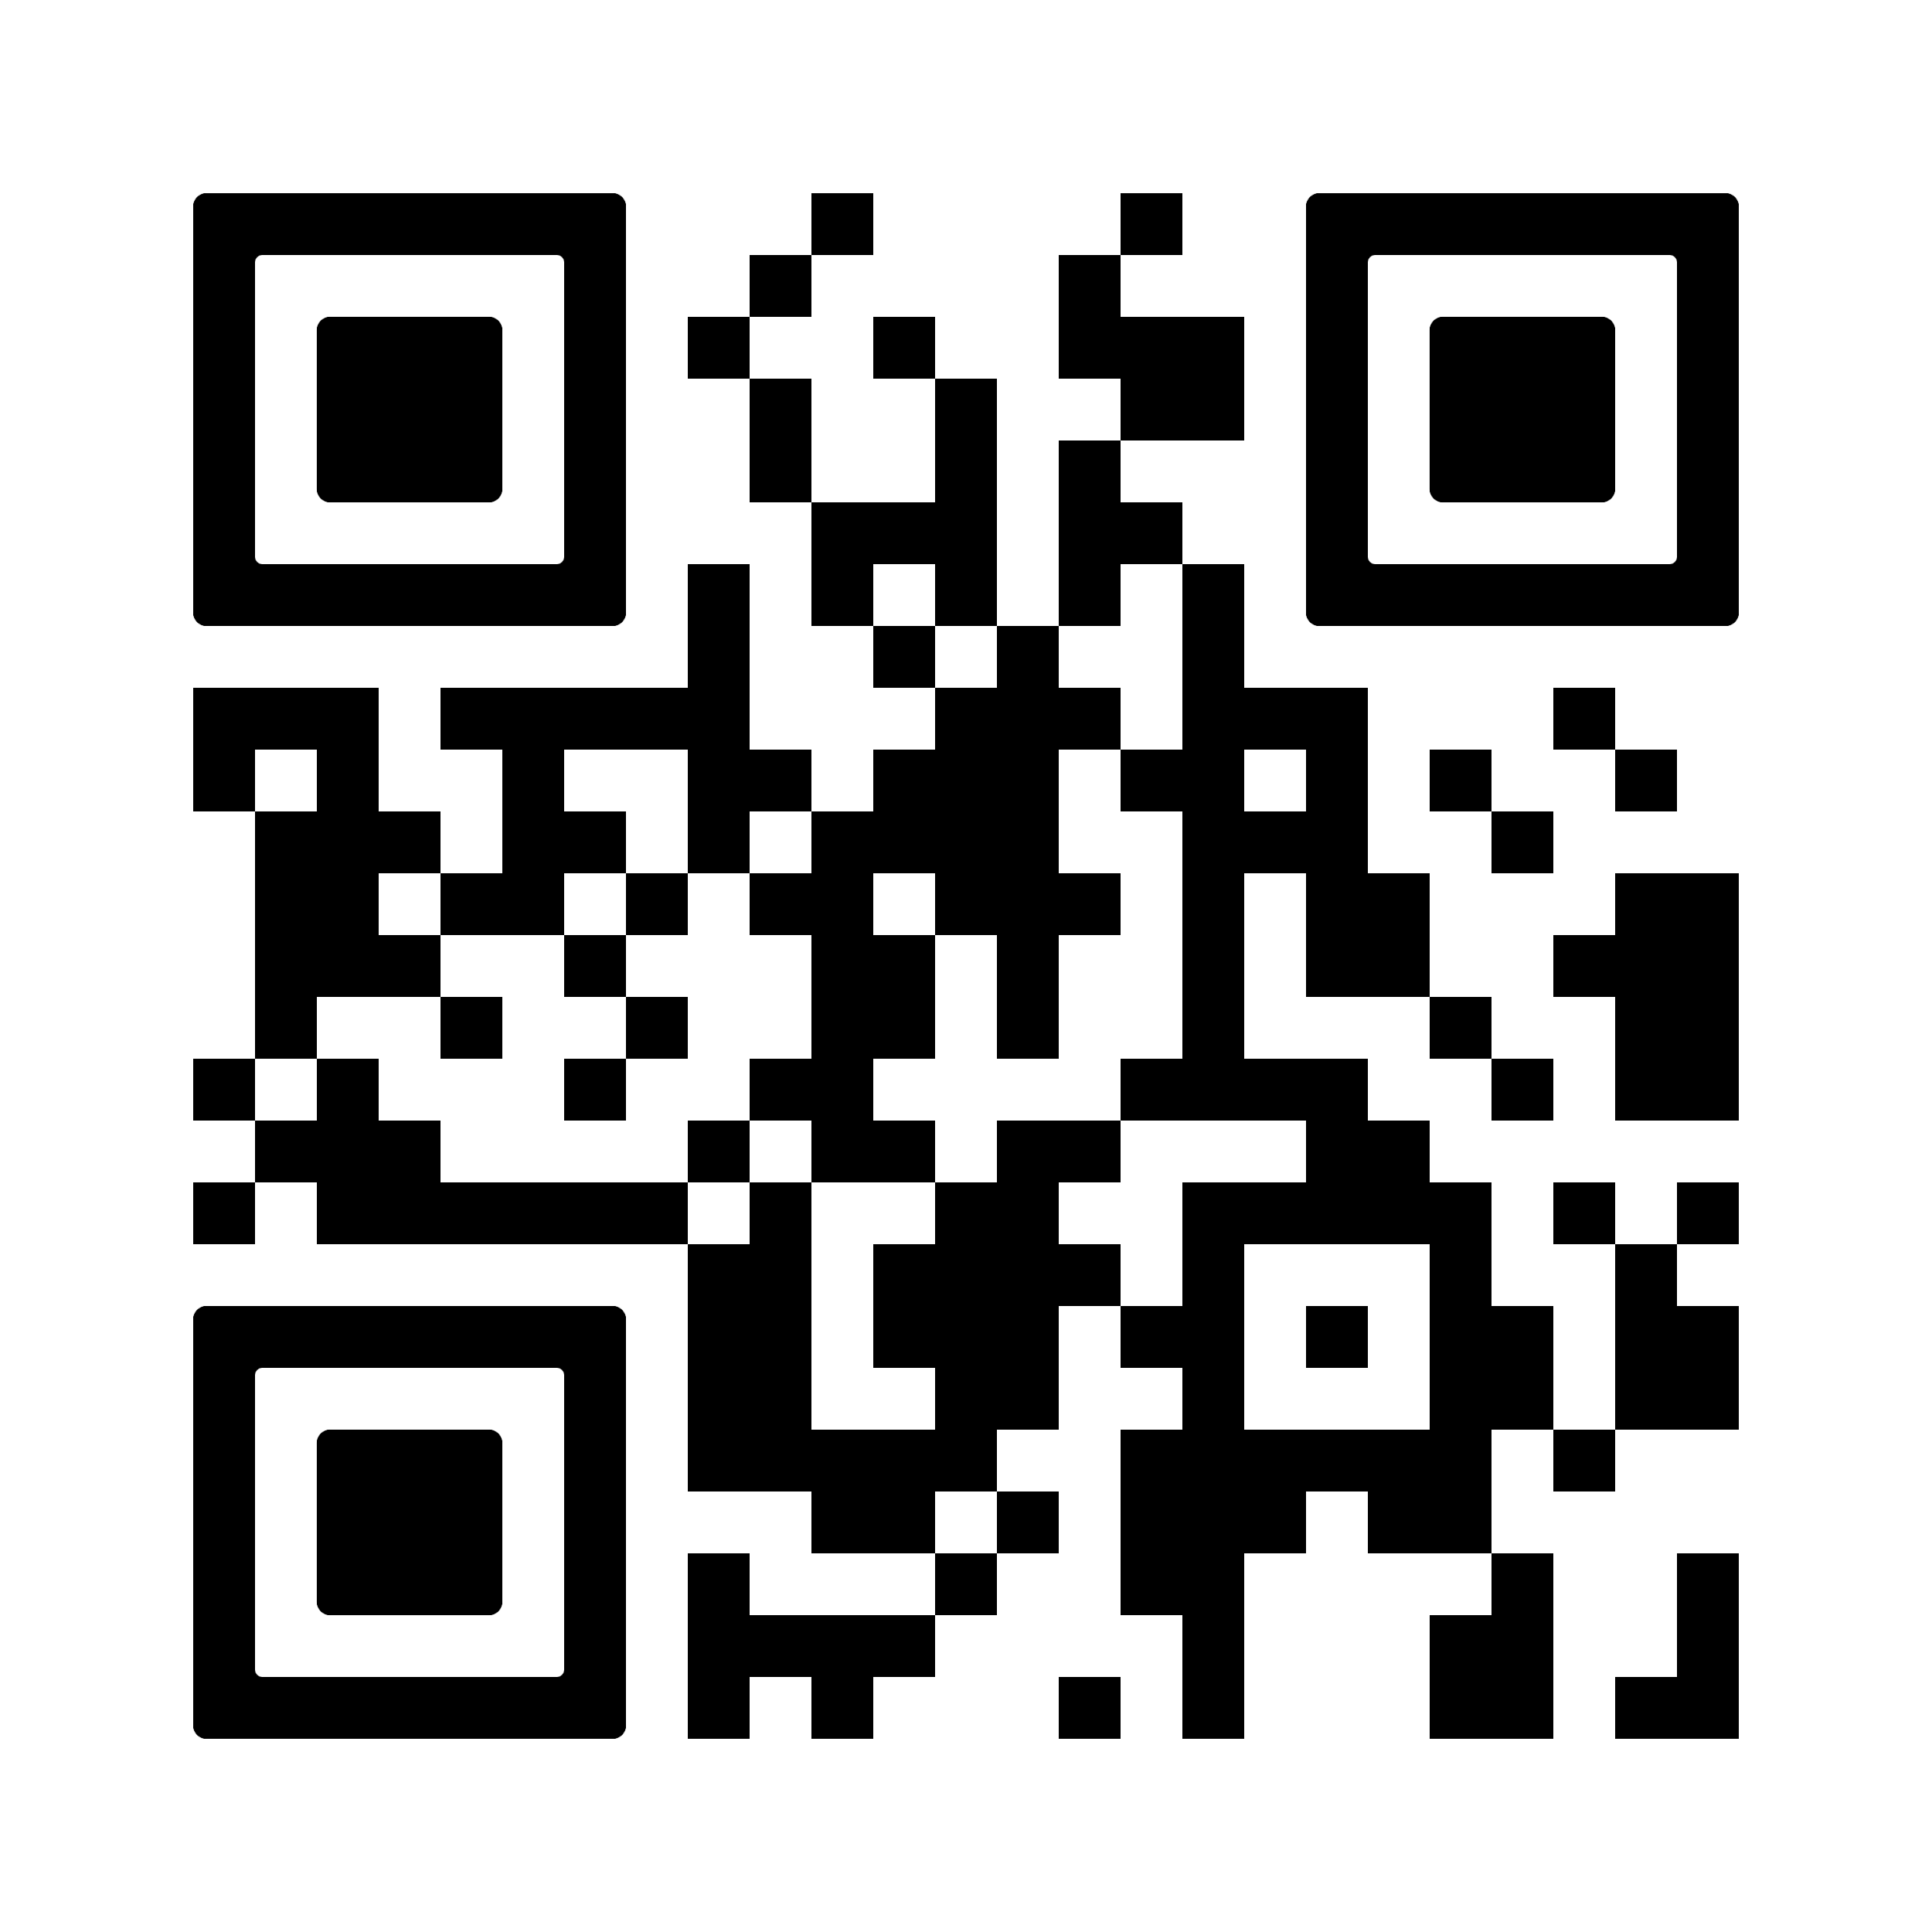

Contact Information:
Brian Hastings (Adult Rocketry Educator)- HastingB@sgasd.org
Nathaniel Hamme (SG NASA SL Team Member)- NathanielHa23@springgrovesd.org

