Paint Night
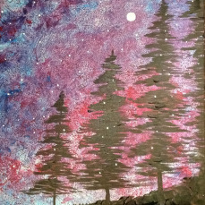
@SGAHS cafeteria--Nov. 14; 6:00-8:30p.m.
We provide all of the materials!
$40-in advanced or $45-at the door
Connie Higgins, our very talented instructor, will go through a step-by-step process to help you create your very OWN masterpiece!
There will be refreshments available to enjoy while painting and spending quality time with your friends and family!
Questions? Please email Brian Hastings at hastingb@sgasd.org
Proceeds benefit Spring Grove Rocketry Program
Doors will open at 5:30pm and light snacks, coffee and ice tea will be available for a donation. CLASS WILL BEGIN PROMPTLY AT 6:00 P.M.
Paint Night Registration Full payment is required at time of registration.
*Registrant’s name: Phone #
Email: Alternate phone?
Mailing Address: State:
City: Zip:
(Please make a copy for other registrants- one per person, please)
FEE Enclosed: make checks payable to SGASD; Mail to Paint Night, c/o SGASD, 1490 Roths Church Road, Spring Grove, PA 17362.
You can also pay online via PayPal. Go to www.springgroverocketry.weebly.com and pay online using our Paypal link.

