Paint Night
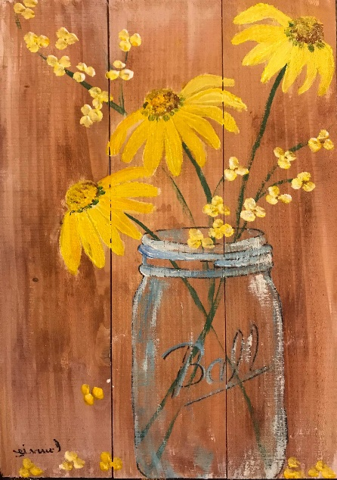
Spring Grove Area High School Cafeteria March 14 6:00-8:30p.m.
We provide all of the materials!
Only $40 to paint this beautiful scene on wood, not canvas, making this unique!
Connie Higgins, our very talented instructor, will go through a step-by-step process to help you create your very OWN masterpiece!
There will be refreshments available while painting and spending quality time with your friends and family!
Questions? Please email Brian Hastings at hastingb@sgasd.org
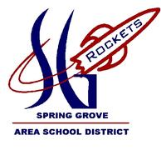
Proceeds benefit the Spring Grove Rocketry Team – Please help us reach our fundraising goal by attending for the Battle of the Rockets Team to compete in Culpeper, VA this April.
Doors will open at 5:30pm and light snacks, coffee and ice tea will be available for a donation.
CLASS WILL BEGIN PROMPTLY AT 6:00 P.M.

Paint Night Registration Full payment is required at time of registration.
*Registrant’s name Phone #
Email: Alternate phone?
Mailing Address: State:
City: Zip:
(Please make a copy for other registrants- one per person, please)
FEE Enclosed: make checks payable to SGASD; Mail to Paint Night, c/o SGASD, 1490 Roths Church Road, Spring Grove, PA 17362.
You can also pay online via PayPal. Go to www.springgroverocketry.weebly.com and pay online using our Paypal link (Just click on blue button to the right that says “Support our Rocket Scientists now”).

