PLAR Post-Launch Assessment Review
Team Name - Project Triton, Spring Grove Area High School
Motor - Aerotech K1000
Payload Description - A test of the effects of G forces on Non-Newtonian fluid
Vehicle dimensions - 4inch Diameter, 24.8 lbs, 108 inches
Altitude reached - The altitude achieved was 4,493 feet. Please see the flight data below for our primary and secondary altimeters. As you can see, the electronics bay was sealed well and there was no appreciable spike in altitude at either ejection charge. The drogue and main chutes acted as planned for a safe recovey.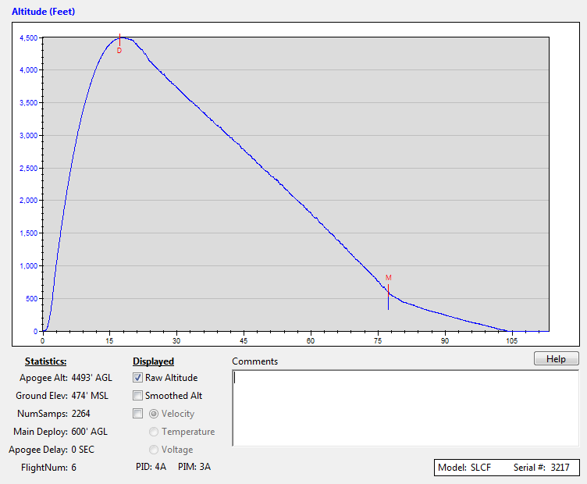
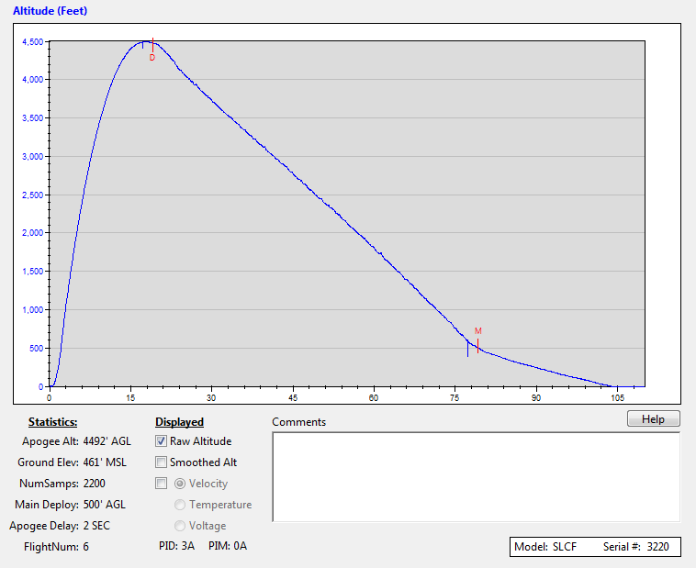
Vehicle Summary - The back section of the rocket is broken off during drogue ejection at apogee. The nose cone and payload breaks off from the front body tube and electronics bay at 600 ft, which were then slowed by the 72 inch Iris Ultra main parachute.
Data Analysis and Results for vehicle - For our results, everything went as planned. The flight was straight, the drogue ejected at apogee, the main ejected at 600 ft, and the vehicle was recovered with no damage. The primary altimeter read 4493ft and the secondary 4492ft. There were very small spikes at the ejection event showing that the electronics bay was sealed securely and was unaffected.
Payload Summary – The payload section was attached to the nose cone and served as the tube coupler for the main parachute separation. When armed, the payload would be triggered by the acceleration of launch as there was a 5.5G switch that would actuate the circuit on launch. The rocket pulled roughly 10G on take-off. Upon actuation, a solenoid would open that was between the top and bottom vial. A timing circuit would also actuate that would keep the solenoid open for 7 seconds and then close it. The time included the burning of the motor and ended just after motor burn out. The solenoid would be closed well before drogue parachute ejection at apogee. There was a non-Newtonian fluid in the top vial and we were trying to see if it would act as a solid or liquid under the acceleration of liftoff. If it acted as a liquid, it would go to the bottom vial upon inspection after launch. If it acted as a solid, it would remain in the top vial after launch.
Data analysis and results of payload – The evidence from our payload was upon visual inspection when the rocket was retrieved and disassembled. When we opened the payload after launch, the obleck was still in the top test supporting our hypothesis that the obleck would solidify under the pressure of G-forces and stay in the top test tube. Upon further inspections the obleck solution actually separated a little with a layer of water on top and a harder powder on the bottom. The electronics of the payload all worked as planned and successfully conducted our experiment. In the future, we could incorporate a camera with small LED lights inside the payload to record the action in real time.
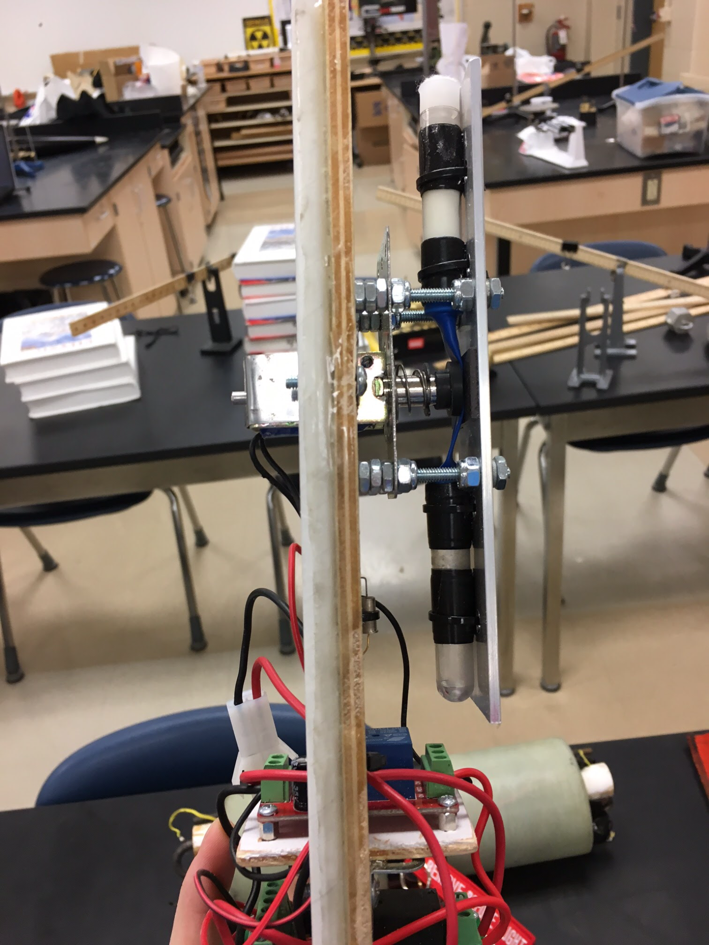
Scientific Value - Our payload results show that the Non-Newtonian fluid solidified during flight. This result has shown that the Non-Newtonian Fluid could be used to protect a fragile payload. When pressure is applied, it solidifies, and it stays as a solid during flight, so it would be perfect for helping insulate a fragile payload.
Visual Data Observed - The flight was very stable, there was little to no wiggle on the way up. We could see that the drogue ejected at apogee and that the main ejection went off at around 600 ft. When the vehicle was recovered, we could see that no damage was done to our rocket.
Lessons learned - A lesson we have learned is that there is up to a 10% difference in motors, which would be the reason why our rocket did not achieve an altitude closer to one mile.
Summary of Overall Experience - As a team, we all had a very educational experience, and have learned the importance of being able to work as a team. Two of our team members are considering a career in Aerospace Engineering.
Educational Engagement Summary - For our Educational Engagement, we have been to Paradise Elementary, Spring Grove Intermediate, West Manheim Elementary, and Windy Hill Senior Center. At Paradise Elementary we showed students the different sizes of rockets, and told them how flight works. Afterwards, the students were able to see a small rocket launch in the field outside the school. At West Manheim Elementary, we showed them what SLI is like, and also showed them our full scale and sub scale rockets. The students were able to ask questions and actually see the different parts of the rockets. At Spring Grove Intermediate, we talked about TARC and the different ways that they are able to get involved with our programs. We also are holding a rocket building workshop at the end of April for those students. At Windy Hill, we showed videos of our launches, and even some of the interviews held at the launch site.
Budget Summary – The proposed budget for the program this year was $21,500. After getting some major sponsors like TE Connectivity ($7500), PA Space Grant Consotium ($2500), Spring Grove Educational Fund ($2500), Engineering Society of York, M&T Bank, Hanover Rotary, etc our budget total was much more attainable. During the year we held fundraisers like selling cotton candy at football games, selling team mission patches, and holding Paint Night events. We ended up meeting our budget goal for this year and was able to fund all of our practice launches, the launch week trip to Huntsville, the educational engagement opportunities, team polos and jackets and supplies for the construction of the rockets.
(below) Photos from Huntsville courtesy of Jim Wilkerson.
