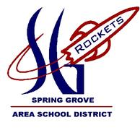
Rocket Building Workshop

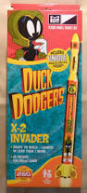
-Held by the Spring Grove Rocketry Team

- Thurs. Nov. 8 5-6pm (small) 6-7pm(medium) 7-8pm(large)
- Fri. Nov. 9 5-6pm (small) 6-7pm(medium) 7-8pm(large)
- Sat. Nov. 10 10-11am (small) 11-12pm(medium) 12-1pm(large)
(circle time)
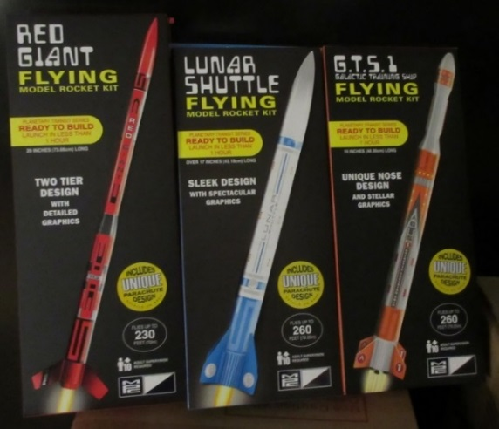
Rocket Building:
Small Rocket- $10
Medium Rocket- $12
Large Rocket- $15

***At least one parent or guardian must be present during workshop and launch***

*Launch opportunity for all participants on Saturday Nov 10 at 2pm*
Motors will be $5 each and will only be paid on site, do not submit with registration
______ number of motors you are interested in purchasing Saturday for the launch
Rocket Workshop Registration Full payment is required at time of registration.
Child’s name: Phone #:
Parent’s name: Alternate Phone #:
Email: Date and time chosen :_______________
(Siblings are welcome to register, please make a copy for other registrants- one per person, please)
FEE Enclosed: make checks payable to SGASD; Mail to: Rocket Building, c/o SGASD, 1490 Roths Church Road, Spring Grove, PA 17362. Payment can also be handed in at the office of your school as well. (cash also accepted as payment)
You can also pay online via PayPal. Go to www.springgroverocketry.weebly.com and pay online using our Paypal link (Just click on blue button to the right that says “Support our Rocket Scientists now”).
Please email hastingb@sgasd.org with any questions.

