Spring Grove Area High School
SLI Rocketry Team Proposal

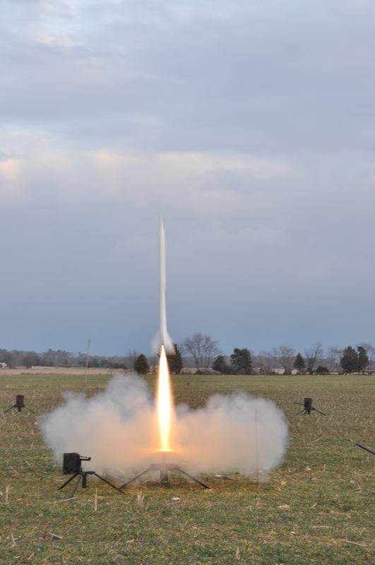

Project Stratosphere
The Rocket Men of Spring Grove

General Information
1. School Information

Name: Spring Grove Area High School
Mailing Address: Spring Grove Area High School
1490 Roth’s Church Road
Spring Grove, PA 17362
Name of Team: The Rocket Men (TRM)

2. Adult Educators:
- Rosemary Cugliari
Spring Grove Area High School Principal
Phone number: (717) 225-4731 ext. 7060
Email: Cugliarr@sgasd.org

- Brian Hastings
Physics teacher, Rocket Scientist Club Coach
Phone number: (717) 225-4731 ext. 7220
Email: Hastingsb@sgasd.org
Education: Honors B.A. in secondary education physics, a masters in science education and 60 graduate credits past my masters degree- Teacher Education Institute

- Renee Eaton
Biology teacher, Rocket Scientist Club Coach
Phone number: (717) 225-4731 ext. 7242
Email: EatonR@sgasd.org
University 2008, MA in Classroom Technology- Wilkes University 2012

3. Safety Officer:
- Tom Aument
NAR Representative
Phone number (cell): (717) 725-4632
Email: blocker1956@comcast.net

4. We are not part of a USLI team, we are a SLI team.

5. Key Managers:

- Brian Hastings- Advisor and Supervisor of students
- Renee Eaton- Advisor and Supervisor of students
- Mr. Sengia- Instructional Technology Specialist
- Veer Pandya- Rocket and Team Leader
- Kyle Abrahims- Co-Captain and Report Head
6. For Launch Assistance, Mentoring, and Reviewing our team will be working with the local NRA representatives along with MDRA(Maryland-Delaware Rocketry Association) for all questions and launches.
Team Members

Name: Brian Hastings
Position: Physics Instructor and Head Coach
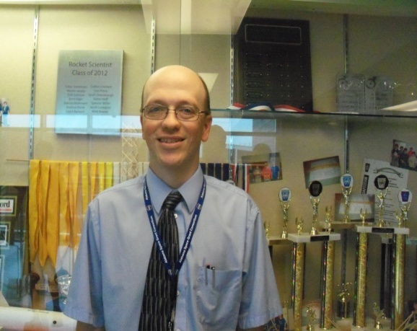
I have been a teacher at Spring Grove for 17 years, teaching Physics 1, Physics 1 Honors, and AP Physics B. I have an Honors B.A. in secondary education Physics, a masters in science education and 60 graduate credits past my Masters Degree. I have taught graduate courses to teachers, and for the past 12 years have taught fast -paced high school physics for Johns Hopkins University’s Center for talented youth program. As a Rocket Scientists’ coach, I have started a Science Olympiad team, a Vex Robotics Team, Physics Olympics Team, and a Team America Rocketry Challenge Team. The Science Olympiad team has advanced to the state level each of the last seven years. We have been participating in TARC for 8 years and have advanced to Nationals each of the past 4 years, placing fourth overall at Nationals in 2012, and eighth at the Nationals in 2013.
Name: Renee Eaton
Position: Biology Teacher and Assistant Coach
I have been a Biology teacher at Spring Grove High School since 2009 . Since then, I have coached the Marching Band and Junior High Track and Field and have advised the Gay-Straight Alliance, Science Fair participants, and the Envirothon team. In addition, I have been a member of the York Jaycees, a local community service organization, since 2009. I am currently working towards my Master’s degree in Classroom Technology, which I will finish in 2013. In my spare time, I enjoy spending time with my friends and family, hiking, biking, reading, and training for 5K races and half-marathons.

Name: Wyatt
Age: 16
Grade: 11
Position: Budget Leader
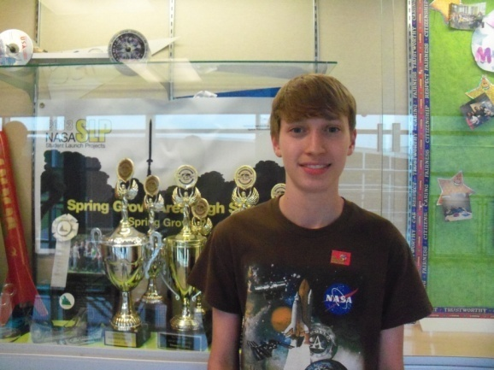
In fourth grade, I participated in my first competition, Math 24, and became the champion for my school. I advanced through the county competition to the state competition, where I received a bronze medal. I became a “rocket scientist” at Spring Grove in eighth grade, when I joined Science Olympiad. I have been in Science Olympiad ever since, and we have advanced to the State competition every year since. My sophomore year was my first for both TARC and the SLP. These experiences taught me how to work with a team, working on a tight schedule, and leadership, among other things. I plan on majoring in some form of engineering when I move on to college.

Name: Kyle
Age: 16
Grade: 11
Position: Co-Captain and Report Head
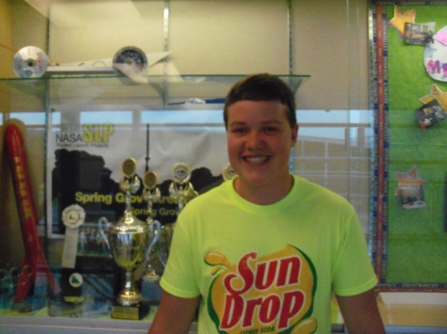
As a student I am involved in many activities throughout the school. I am a part of the Science Olympiad team that has made it to States' the past 5 years in a row including a 12th place finish in 2013. I am a part of TARC and am currently working with my team as a captain to make it to Nationals' for the first time. I am also in our High Schools Envirothon team as well as Globetrekkers'; a language based program for High School and Elementary level kids to learn foreign languages such as Spanish. I also volunteer over the summer at many youth basketball camps as a counselor and love to see the kids' grow and learn. This year I will be taking on the challenge of Co-Captain for the SLI team, a job that I plan to take charge of. The Student Launch Projects are a dream of mine to create my own rocket and watch it grow with us ever since I have been a kid and learned of space. In my free I race my go-kart around the country. In the future I plan to get a bachelors' degree in Chemistry from either Pittsburgh or Temple University and then go on to Medical School to become an Orthopedic Surgeon.

Name: Veer
Age: 17
Grade: 12
Position: Rocket Construction Head and Captain
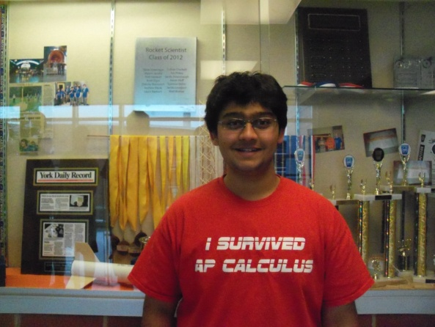
In 8th grade, I became part of Spring Grove’s science clubs by joining Science Olympiad. Our school’s teams have made it to the state level competition for the last seven years. In 9th grade, I joined a Team America Rocketry Challenge (TARC) team here. Last year I took initiative in my team to become the captain. We went to nationals, where we competed with 100 teams from across the nation. This was a very fun yet educational learning experience where I learned firsthand not only the basics of rocket science, but I also gained knowledge of how it feels to compete amongst so many people and how to cope up with the immense pressure generated at this level. I also acquired invaluable leadership skills through these experiences. I joined one of our school’s VEX robotics teams in 9th grade as well. In the last few years Spring Grove’s robotics teams have competed locally with other nearby schools districts. To compete in the competition you had to make a robot that could perform in various challenges. This competition runs in the spring and fall. Last year, I created my own team for the spring VEX competition and we placed third overall. I was part of our school’s Physics Olympics team where we competed locally to test our knowledge of physics. In 7th grade, I received my black belt after four years in Tae-Kwon-Do. In 10th grade, I joined our school’s tennis team. This year, I plan on participating in Science Olympiad, leading a TARC team, leading a VEX team, competing in Physics Olympics, participating in SLI, and playing tennis. In 5th grade, I became a part of John Hopkins Center for Talented Youth (CTY). I was in the program called Individually Paced Mathematics where I taught myself most of 6th grade math. I completed another course for CTY in my 6th grade summer called Robotics. There, I learned the basics of robot design and programming by working with Lego’s Robot Mindstorm kits. I completed my last CTY class, Electrical Engineering, over the summer of my 8th grade year. In this program, I learned many basic principles and techniques ranging from solving problems, acquiring knowledge in the field, breadboarding and soldering circuits together. Thanks to this great experience, I plan on majoring in Electrical Engineering when I move on to college.

Name: Josh Staley
Age: 16
Grade:10
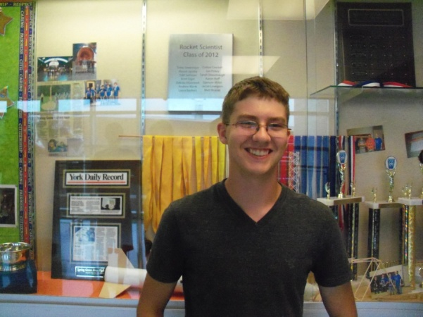
I became interested in science when I joined the Evironthon team in 7th grade. I began taking part in Science Olympiad the following year and have made it to the State competition each year since joining the team. I started learning about rockets in my freshmen year when I took part in Team America Rocket Challenge. I am also a member of the book club, German American Partnership Program, and I have played violin since 3rd grade. This year, I am looking forward to being a SLI team member.

Carter Forry
Age 17
Grade 12
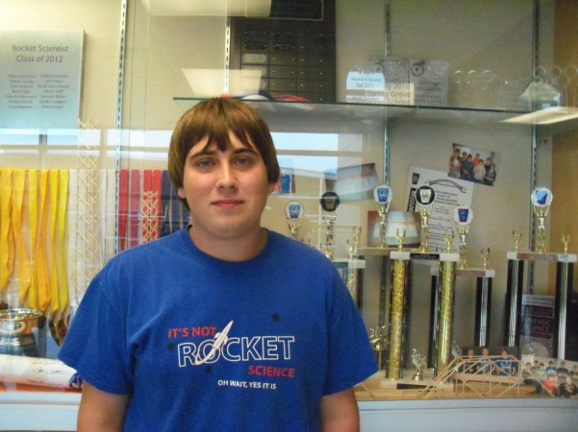
I’ve been in other science programs and completions, but SLI is the most rewarding and has the best experience. SLI is an opportunity that very few high school students get to partake in. It makes the student look better on applications and also makes the school look better as a whole. SLI also gives valuable insight into what engineering actually can be; groups of likeminded people working together to complete a difficult task. My experience in SLI will have helped me should my future career as an engineer.

Matt Sheehan
Grade 12
Age:17
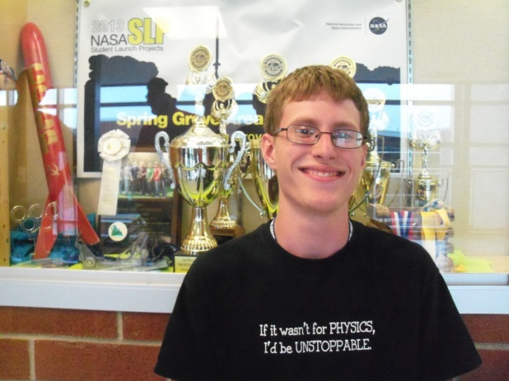
Participating in SLI was the most significant thing I did last year. It was certainly a fun experience to build such a large rocket and learn about NASA’s projects. I am currently in TARC, which I have been a part of since 9th grade. Last year our team got 9th in nationals. Two years ago, our team made it to nationals but didn’t do quite so well. I’m also going to be in Physics Olympics again this year, which my team got 2nd place in last year. I participated in VEX Robotics for two years as well. Two years ago I got my black belt in Tae-Kwon-Do after four years of practice. I was also on the varsity tennis team two years ago. I plan on going to college to get a degree in Engineering.

Albert Taglieri
Grade:11
Age:16
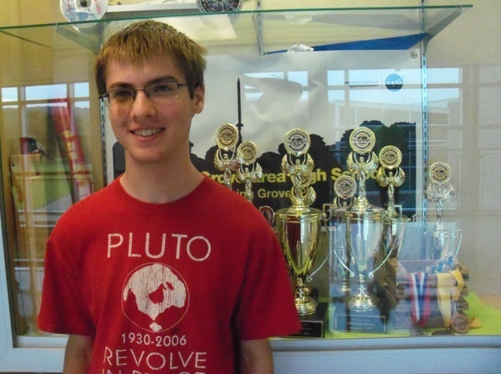
A student entering his junior year, Albert is gifted in math and science. He has the goal of double majoring in Aerospace Engineering and Computer Science through Air Force ROTC. He is a previous member of the York County Honors Choirs and County Band. He is a member of the Civil Air Patrol, and many clubs at school including the Rocket Scientists, Tech club, Choir, Band, Orchestra, and is starting a team for the CyberPatriot competition. He is currently a captain of a team in the Team America Rocketry Challenge. He is an active member of the CREW Youth Group, and of the Worship Team at Providence Presbyterian Church. He is an honors student who has taken AP Physics B, and scored a 5 on the AP exam, and this year is taking the AP Calculus AB and AP Chemistry classes and exams. He is currently registered in the College in the High School program with HACC for a semester long course offered at Spring Grove. He progressed in middle school to the State Level MATHCOUNTS competition, placing 38th in the individual round. He also advanced into the AIME in the 2012-2013 school year after being twice the school winner of the AMC 10 and being awarded a bronze medal. He is currently seventh in his class rank after sophomore year.

Luke Walko
Grade:12
Age:18
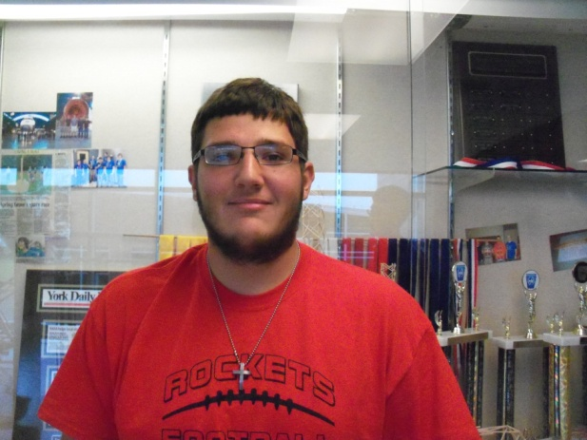
I am currently working on the SLI Project. This year I will also participate in TARC for the third year in a row, out of which my team has gone to Nationals two times in a row. I also participate on the football team, wrestling team, and the National Honor Society. Also, earlier this year I obtained the rank of an Eagle Scout, which in my opinion is one of my greatest accomplishments. My main interests include science, math and engineering. I have always liked to build things out of anything I could get my hands on, whether it be Legos', model kits, wood or anything else. I also like to take things apart and figure out how they work. I plan on attending a university for aerospace engineering next fall.

David Williams
Age: 16
Grade: 10
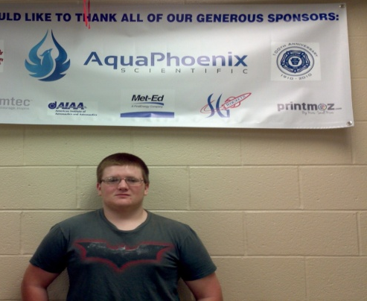
SLI is an excellent and great opportunity for me, I feel honored to be part of the program again it is truly a grate opportunity to learn about the engineering field I would like to enter after high school. I will be able to contribute to projects like these in the future with great understanding of what I’m doing because this is after all our schools second year of working on such a project. I love this project and in the near future I hope it gets me wear I want to go in life, thus launching me on my career path.

Andrew Whitman
Age: 17
Grade: 12th

Back in Middle School I first got involved with clubs/competitions through the Math 24 competition. Since then, I’ve been a part of TARC, Globe Trekkers, several math competitions, and now the SLI project. Last year, our TARC team finished in the top ten at nationals, an achievement I’m ready to put on my resume with pride. Math and Science are subject fields I greatly enjoy. The experiences I’ve had so far in those areas have been great and fun, and they’ve also helped me learn a lot. Because of my enjoyment from these, I’ve decided to go to school for engineering. Outside of school, I participate in the NHRA Junior Drag Racing League, something I have been a part of since I was eight years old.

Facilities and Equipment
- Description of Facilities/Personnel/Equipment/Supplies
  - Spring Grove High School:
  - Hours: Monday through Friday 7:25 A.M. until 2:30 P.M. and after school upon instructor availability.
    - Room 135:
      - Gravograph LS100 30W laser
      - Structural Stress Analyzer 100
      - Computers with Microsoft Office and Solidworks
    - Room 130
      - AXYZ Automation INnc 2.2kW 18kRPM TypeB 12-2 CNC Router
      - Compound Dewalt miter saw
      - Framarbandsaw
      - 24” Planer
      - Paasche FABSF-6 spray booth
      - Belt sander
      - Drill press
      - Oliver table saw
      - Orbital sander
    - Room 131
      - Lab Volt 5400 CNC Mill
      - Lab Volt Automation 5500-B0 CNC Lathe
      - EMCO Concept Mill
      - General Model 480 Jointer
      - Jet Benchtop drum sander
      - Victor Metal Lathes
      - Tennsmith sheet metal cutter
      - Miller Spot Welder
      - Baldor Grinder/buffer
    - Room 220
      - Computers with Rocksim9 and Logger Pro
      - Labquests
      - Drill press
      - Belt sander
      - Reciprocating saw
      - Circular saw
      - Cordless drill
    - Room 242
      - Storage and workspace
    - Room 221
      - Fume hoods
      - Laptop cart with 28 IBM Thinkpads
  - Launch site: MDRA Launch field requires an MDRA member for supervision whenever one is free to supervise
  - Materials/Supplies
    - There is an abundance of supplies in Room 220
    - All other needed supplies will be ordered at the appropriate time
- Description of Computer Equipment/WebEx required supplies
  - Conference rooms 50 and 51
    - Laptop computers
    - USB web camera
    - Cisco speakerphone
    - School network connection
WebEx/connectivity Instructor Contact Information:
Instructional Technology Specialist: Mr.Sengia
Email: Sengiaj@sgasd.org
Phone number: (717)-225-4731 ext.7060
3. The Spring Grove SLI Team will implement the Architectural and Transportation Barriers Compliance Board Electronic and Information Technology (EIT) Accessibility Standards (36 CFR Part 1194) Subpart B- Technical Standards 1194.21 (a-l), 1194.22 (a-p), and 1194.26 (a-d). They can be found at: http://ecfr.gpoaccess.gov/cgi/t/text/textidx?
c=ecfr&tpl=/ecfrbrowse/Title36/36cfr1194_main_02.tpl

Safety
1. Safety Plan:
Before any work is done on the rocket, a second mandatory safety meeting will take place to re-inform students of the NAR safety code. When handling potentially hazardous materials, students will be required to read the Materials Safety Data Sheet (MSDS) on the hazardous material. This will be done before they can work with the material. Team members are to handle the material according to the Materials Safety Data Sheet, including, but not limited to, the handling and storage of the material.
The SLI rocket will be constructed in the Spring Grove Area High School. Students will have quick access to the following safety materials: Sellstrom SM Z87+FF Safety Goggles, Splash Aprons, Emergency Eye Wash Stations, Emergency Body Wash Stations, Cantflame Fire Blankets, BFPE type ABC Dry Chemical Fire Extinguishers regularly serviced by Dale E. Ness Inc., and Simplex Fire Alarms. In all rooms where rockets will be assembled and prepared, there are fire detection and suppression systems present. There are also sprinklers in all rooms. We also plan on using nitrile gloves and respirators as the MSDS sheets suggest. These will be used for the handling of potentially hazardous materials.
We have appointed a construction safety officer who is required to certify that all materials and building procedures are in conformance with the NAR High Power Rocketry Safety codes. This construction safety officer has also been appointed as our range safety officer. He will also certify that the launch facility, rocket engine components, and environmental conditions are within safety regulation requirements. Our Safety Officer will be Tom Aument. Mr. Aument will be responsible for the safety and handling of the rocket motors. He is also responsible for the safety of all of the Spring Grove SLI participants while he is handling a motor. In addition, he will oversee the construction of the project and will ensure that the Safety Plan is being followed throughout the entire project. Mr. Aument is NAR Level 2 certified. Therefore, he will also be responsible for the ordering and storage of our rocket motors.
We will incorporate safety as an integral part of the design. The rocket will also be safely inspected and checked throughout the construction. In addition to the safety plan, we will be following the NAR High Power Safety Code guidelines as outlined below:
Risks | Probability of Risk *(1-10) | Impact on Project Progress | Mitigations
The payload may get lodged in rocket such that it comes down with the rocket and yields no usable data. | 2 | We will need to redesign, rebuild, or reload the payload. This would delay the progress of construction. | The team shall ensure that the payload is properly installed.
The rocket parachute does not deploy and rocket returns unsafely to the ground. | 3 | We lose a rocket and must build another one, losing work time and time to launch. | The team will carefully insert the parachute and make sure there is enough heat shield the ground material to prevent flame up.
Injury could occur while using coping saw. | 2 | A leave of absence of a team member could occur due to minor or severe injury and possibly delay the rocket-building progress. | The team will be aware of limbs and fingers when using this tool.
Injury could occur during Exacto knife usage. | 5 | A small injury could occur, possibly delaying the rocket-building progress. | The team will carry the knife in cautious matter, cut away from oneself, and be aware fingers when using this tool.
Accidental combustion of rocket materials | 3 | In addition, possible injury and a delay of rocket-building progress could occur. | The team will keep 25 feet away from electrical outlets, open flame, and the indoor magazine.
Allergic reactions to chemicals involved in rocket production | 2 | Minor or severe chemical burns of team members and possible delay of rocket progress could occur. | The team will make all students aware of each other’s allergies and stay away from possible allergens.
Electrocution during electrical outlet usage | 1 | Minor or severe injury could occur. | The team will only use electrical outlets if hands are dry and static free. The team will keep fingers away from prongs.
Adhesion to materials or self | 4 | Minor injury and very minor delay of rocket progress could occur. | The team will exercise proper caution when  handling adhesive material and will not use too much of the material.
Injury during laser engraver usage | 2 | Possible combustion of rocket materials could lead to reordering of materials and delay progress. | The team will make sure the laser is on the proper power, speed, and focus settings, and ensure that the exhaust fan is on.
Injury during drill press usage | 2 | Severe injury and delay of progress could occur. | The team will keep clothing, hair, and body parts away from the drill bit and use safety glasses.
Tripping and falling hazards | 3 | Minor or severe injury, delay of rocket progress could occur. | The team will make sure the walking path is clear and keep clutter off of floor.
Abrasions and bruises caused by belt sander | 2 | Minor injury and delay of progress. | The team will keep hands and clothing away from the sandpaper.
Burning caused by soldering iron usage | 2 | Minor injury and delay of progress. | The team will use soldering iron in a proper manner and use safety gear.
Premature ignition of rocket motors | 2 | Possible minor or severe injury, the need to reorder rocket motors, and delay of rocket progress. | Ensure that only the proper level certified personal handle the rocket motors and installations as well as reloads.
Team estrangement because of lack of cooperation | 1 | Delay of rocket progress. | The team will talk calmly and will not fight with one another. The team will respect each other and themselves.
Going over-budget | 5 | Delay of rocket progress due to the need for more time to fundraise | The team will carefully use all materials, order only the parts needed, keep track of materials, and use the budget wisely. The team will be diligent in fundraising endeavors.
Misuse or mishandling of hazardous materials | 2 | Minor or severe injury, leave of absence for team member affected, and delay of progress | The team will follow all safety code regulations, laws, and instructions.
Unforeseen rocket design complications | 4 | Delay of rocket design and rocket building progress | The team will design a stable rocket based on the locations of the center of pressure and center of gravity. The team will also have a NAR representative check rocket design.
Unforeseen payload design complications | 3 | Delay of payload design and production. | The team will design a payload that will be effective for the size body tube that is used and double-check that the components of the payload are properly wired and attached.
Complications during transportation of participants and materials to SLI or practice launch sites | 3 | Delay of rocket progress due to rocket repairs or cancellation of practice flights because of extensive damage. | The team will make sure that the launch date is known in advanced and that all specifications are planned out well in advanced. The team will pack the rocket well and make sure it is secure during transportation.
Accidental partial or complete destruction of building site | 2 | Damage to work environment, additional expenditures for repairs, possible progress delay. | The team will ensure that safety guidelines from NAR and the MSDS are being followed.
Team communication failure | 3 | Rocket/payload may be built incorrectly or too many of one part may be made, causing a slight to major delay of progress or loss of material. | Every team member will have access to other members’ email addresses and have the ability to talk during the school day.
Shortage of rocket building materials | 2 | Major delay due to the need to order new material and wait for it to ship. | The team will double- check all materials before ordering and enforce a checklist while parts are being used.
Commitment complications among team members | 2 | Loss of time or team member if the complication is too great. | The team will make sure all team members make this their first priority and plan accordingly.
Inhalation of dangerous fumes | 2 | Minor to severe injury, time lost taking student to ER, delay of progress. | The team will wear proper safety gear, exercise proper use of fume hoods, and be aware of surroundings.
Accidental ingestion of rocket materials | 1 | Minor to severe injury, delay of progress, possible loss of material. | Only experienced students should work with dangerous materials under proper supervision.
Motor ignition delay | 3 | Launch delay, loss of motor if it does not ignite, minor to severe injury if motor ignites while personnel are approaching rocket. | The team will only use commercially available and Range Safety Officer-approved igniters.
Rocket catches fire on the launch pad | 2 | Possible loss of rocket, minor to severe injuries if fire is not properly extinguished. | The team will bring a fire extinguisher suitable for the needs of the fire and according to the MSDS of the motors being used.
Cancellation of launch due to poor conditions | 4 | Delay of testing. | The team will plan multiple days to launch, be flexible in scheduling practice launches, and practice patience.
Motor ignition failure | 3 | Delay of launch testing and rocket progress. | The team will ensure that commercially available igniters and motors are used and follow the NAR High Power Safety Code, which outlines what to do during motor ignition failure.

*Probability is rated on a scale of 1 to 10, where 1 represents a low probability that the risk will present a problem and a 10 represents a very high probability that the risk will present a problem. Risks that are rated at ten or close to ten will be dealt with as soon as possible and handled according to the mitigation and/ the best way to handle the problem.
2. Procedures for NAR/TRA Personnel to Perform:

Tom Aument is our Level II NAR mentor as well as our safety officer. He will be certifying that the rocket motors that we are using are certified and safe for launch. He will also be ensuring that the engine reload kits are certified and safe for us to use. Mr. Aument will also be overseeing the construction of the rocket to ensure that the rocket will only be constructed out of light-weight materials such as paper, wood, rubber, plastic, fiberglass, or, if necessary, ductile metal. He will visit occasionally to inform tem members about better construction methods and how to build safely.
Mr. Aument will verify that the rocket engines and engine reload kits are not broken upon delivery. He will also store the engines and reload kits in a locked Type 4 magazine that meets the requirements of NFPA 1127. He will verify that no sources of fire or heat are within 15 feet of the locker and 25 feet of the rocket motors when they are being used. Mr. Aument will keep an inventory of the engines and reload kits and an adult supervisor will also ensure the completion of the above steps by the safety officer.
Mr. Aument will be responsible for controlling the inventory of all engines and rocket motor reload kits. When ready for use, he will also update the inventory of the rocket motors and reload kits to ensure that there are no missing supplies. Engines and reload kits that are not used for flight, but have been checked out for use, will be returned to Mr. Aument and accounted for in the inventory. Engines and reload kits will be documented with the launch location for that particular motor or reload kit, the date and time it was used in a flight, and the number of the flight. Mr. Aument will also be ensuring that safety equipment for hazardous materials and handling procedures for hazardous materials are being followed based on the Materials Safety Data Sheets for those materials.
3. Plan for Briefing Students:
Students will be required to participate in an introductory meeting, includinga reading of the NAR High Power Rocketry Safety Code to all members of the team. Team members shall also be required to attend more meetings covering the safety codes of the NFPA and FFA. During the meetings, NAR High Power Rocketry Safety Code shall be reviewed again. Examples from past experience will be used to put the discussions in perspective. Materials will be shown to all team members and they will be told of the hazards of the materials before they are able to use them.
Meetings will be held prior to launches as well. In these meetings, safety codes will be reviewed, team members will be made aware of the hazardous equipment, and team members will be informed of how to avoid other accidents.
4. Methods for Including Necessary Caution Statements:
In order to ensure that cautionary statements are included in plans, procedures, and other working documents, we plan to post warning signs on the entrances of the room in which the indoor magazine will be placed. Cautionary statements will be placed on the entrance of room 220 to ensure that participants are aware that hazardous materials are being stored in the vicinity as well. To ensure hazardous adhesives and accelerants are handled with care, warnings will be posted on the door of the cabinet where they are stored to notify users of the risks involved with these materials. We plan on posting the Materials Safety Data Sheet for the motors being used outside of the room in which it will be stored for team members to read before entering the room. In the planned documents we also plan to include detailed plans of our safety plan and any other plans to keep everyone safe such as securing the launch site and reading all postings' on machines and launch fields.
5. Plan for Complying with Laws:
In order to comply with federal, state, and local laws regarding unmanned rocket launches and motor handling, the Spring Grove SLI team shall launch its rocket so that it stays in a suborbital trajectory. The team shall also launch the rocket so that it does not cross into the territory of a foreign country, and the rocket shall be unmanned. The rocket shall be launched in a manner that does not create a hazard for any persons, property, or other aircraft. The team rocket shall also be subject to any additional operating limitations necessary to ensure that air traffic is not adversely affected, and to ensure that public safety is not jeopardized.
To ensure further compliance with FAA regulations, the team shall also avoid launching the rocket at any altitude where clouds or other obscuring phenomena of more than five-tenths coverage prevails. This shall include not launching the rocket at any altitude where the horizontal visibility is less than five miles and not launching the rocket into any cloud. The rocket shall not be launched between sunset and sunrise without prior authorization from the FAA and will not be launched within 9.26 kilometers of any airport boundary without prior authorization from the FAA. The team shall not launch the rocket in controlled airspace.
The Class 2 rocket shall not be launched unless the team observes that there are appropriate separation distances between the launch site and any person or property that is not associated with the operations. The separation should not be less than one-quarter the maximum expected altitude or 457 meters (1,500 ft.), unless a person of at least eighteen years old is present and is charged with ensuring the safety of the operation, and has final approval from authority for initiating high-power rocket flight and unless reasonable precautions are provided to report and control a fire caused by rocket activities.
The Spring Grove SLI team shall give the FAA and ATC facility nearest to the place of intended operation the following information no less than 24 hours before and no more than three days before beginning the operation:
a) The name and address of the event launch coordinator, whose duties include coordination of the required launch data estimates and coordinating the launch event;
b) Date and time the activity will begin;
c) Radius of the affected area on the ground in nautical miles;
d) Location of the center of the affected area in latitude and longitudinal coordinates;
e) Highest affected altitude;
f) Duration of the activity;
g) Any other pertinent information requested by the ATC facility.
The Spring Grove SLI team shall also research state and local laws regarding rocketry in order to ensure compliance with all laws associated with rocketry in the vicinity of the rocket launch site. The team shall also be in compliance with all rules and regulations regarding rocket launch sites, rocket motor storage, and rocket launch safety described in NFPA 1127.
6. Plan for Motor Handling and Storage:
Rocket motors will be purchased through our NAR level II certified representative, Tom Aument. All motors will be stored within a Type 4 magazine and access will be granted solely to our NAR representative. Mr. Aument will be responsible for the safe transportation and construction of the rocket motor reloads. Any use of the motor will be under his supervision at all times.
7. Team Agreements:
Spring Grove SLI Team Agreements:
As a team member:
1. I agree to comply with all applicable local, federal and state laws.

2. I agree to use of airspace laws of Federal Aviation Regulations 14 CFR, Subchapter F, Part 101, Subpart C.

3. I agree to handle and use low explosives according to the Code of Federal Regulation 27 Part 55: Commerce in Explosives.
25

4. I also agree to follow all fire safety regulations according to NFPA 1127 “Code for High Power Rocket Motors.”

5. I will follow the NAR High Power Rocketry Safety Code.

6. I agree to read the Material Safety Data Sheet and follow all of its instructions. I will be aware of the hazards that are involved with the materials that we are using in our project. This includes, but is not limited to, the rocket motor.

7. I will use safety equipment in accordance to its safety regulations during the construction of the rocket.

8. I will obey all instructions given by the project manager and supervisors.

9. I agree to work with my team members in a constructive manner in order to make a safe environment for all team members to work together.

10. I am committed to working on this team until the completion of our project.

11. As a team member, I promise to show up to 75 percent or more of all meetings and do my work when I am assigned and do my work to the best of your own ability.

As a team:
A. We agree that there will be range safety inspections for each of our rockets before they are flown. Upon inspection, we will comply with the determination of the safety inspection.

B. We agree that The Range Safety Officer has the final say on all rocket safety issues. Therefore, The Range Safety Officer has the right to deny the launch of any of our rockets for safety reasons.

C. We agree that if our team that does not comply with the safety requirements we will not be able to launch our rocket.

I agree to the Spring Grove SLI Team Agreements above. I understand that any violation of these rules will result in consequences including getting taken off the team.
Name: ___________________ Signature: _____________________ Date:_____________

Technical Design

Part D
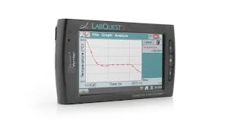
The goal of our unique payload is to determine the effects on the magnetic field and radiation a mile above the Earth. There plans to be a barometer to measure the atmospheric pressure, which we will also use its data and the other data collected to compare the pressure change to measure altitude. The last sensor is a dual range for sensor to measure how many g’s the rocket does on launch.
The piece of equipment that will be collecting the data from the four sensors is the Labquest®2. The Labquest®2 can take in 100,000 individual pieces of information in every second, and has enough memory to hold the information for all four sensors. The Labquest®2 is easily accessible to analyze the collected data.
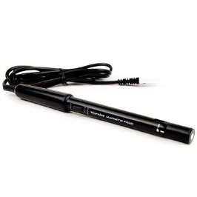
The first sensor is the magnetic field senor. Our goal of this sensor is to analyze how the Earth’s magnetic field changes with altitude. Then we will be able to come up with a mathematical relationship between magnetic field strength based on the change in altitude. The hypothesis for the data from the magnetic field sensor is that the magnetic field will be weaker with a higher altitude. The rocket won’t go a large distance towards the Earth’s poles so that wouldn’t change the magnetic field. Most likely we will see a $\frac{1}{r^{2}}$ relationship between the distance from Earth and the strength of the magnetic field.
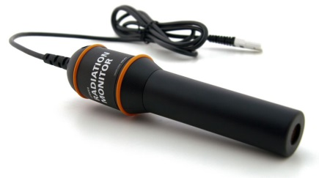
The second sensor is the radiation sensor. This sensor will measure the radiation during the whole flight. The change in radiation will also allow us to come up with a mathematical relationship between the radiation and the change in altitude. This will also give us an idea of how much the Earth’s atmosphere blocks harmful radiation from the sun. The hypothesis for the data of radiation is that there will be more radiation with an increase in altitude. The main part of Earth’s atmosphere that blocks harmful radiation is the ozone layer which is over 12 miles up. Most of the harmful radiation is blocked there, but some radiation still gets through. The relationship might not be a $\frac{1}{r^{2}}$ , but there will be more radiation with altitude.
The third sensor is the dual range force sensor. Currently Vernier doesn’t have an accelerometer that can measure above 25 g’s. Last year’s rocket did 46g’s, so we are planning to use a force gauge with a small attached mass. The measured force reading can then be converted into how many g’s the rocket did. The mass will have to be around 0.10kg to say under 50N assuming the rocket does around the same amount of g’s as last year. The mass will be secured to the hook of the force meter and won’t be able to rotate, so the only motion the mass will be able to do is up or down.
The last sensor is the barometer. This sensor will measure the atmospheric pressure. This sensor will serve a dual purpose. The first purpose is to measure the change in atmospheric pressure and then we can calculate a mathematical relationship from that. The second purpose is to calculate an altitude change based on the change in atmospheric pressure. We can then compare this calculated altitude change to the measured altitude change from the rockets altimeter. Our expectations for this sensor are that the calculated height from the data will be close to that of the rockets altimeter. The same concept is used to get the change in altitude in the altimeter and the barometer. Air pressure .vs. change in altitude should also be a $\frac{1}{r^{2}}$ relationship as well.
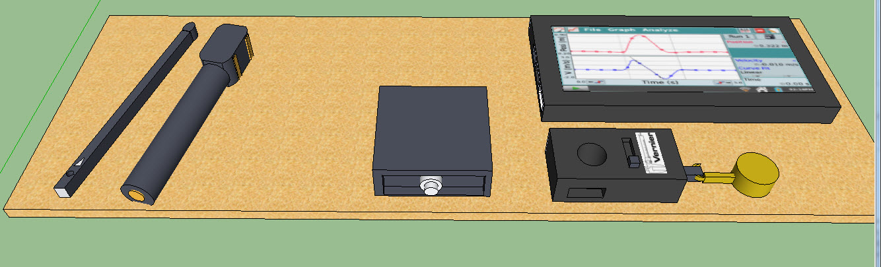
The way the sensors are going to be kept in place is on a wooden board that fits into the payload tube. (Wires not shown)

On the board there will be a wooden skeleton that keeps the sensors in place. There are holes cut out of the skeleton where the sensor’s sensor will be and on the sensors and Labquest®2’s ports. There will be no frame on the hanging mass so the mass doesn’t rub against anything that would be a source of error in the experiment. To keep the equipment safe memory foam can be placed under the sensors and around the edges.
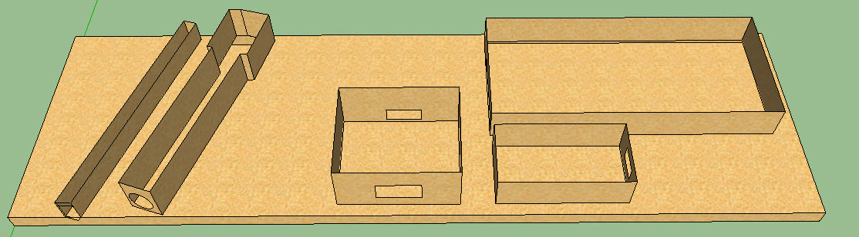
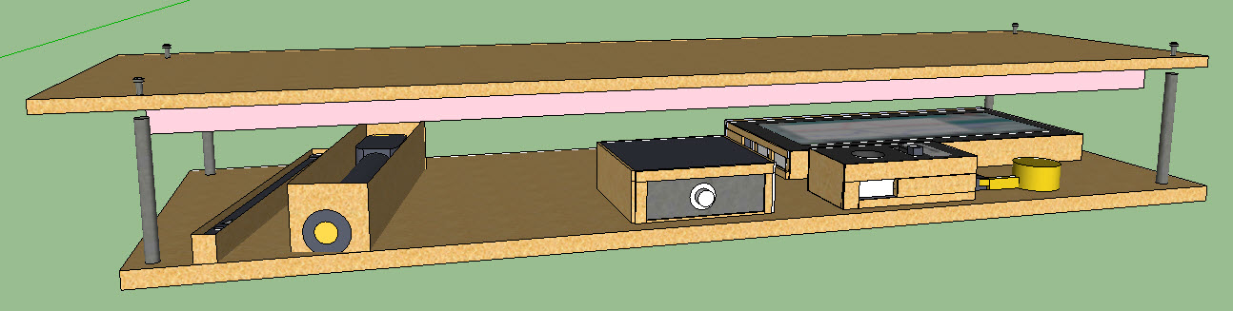
The wooden skeleton will protect the equipment from moving side to side. Another piece of wood will have a layer of memory foam attached to it and will be placed against the face of the sensors. The memory foam can be sculpted to the shape of the equipment so that the right amount of protection can be on what is needed. There will also be no memory foam above the hanging mass to prevent friction. To hold the two pieces of wood together there will be four rods that a screw can be inserted on both ends.

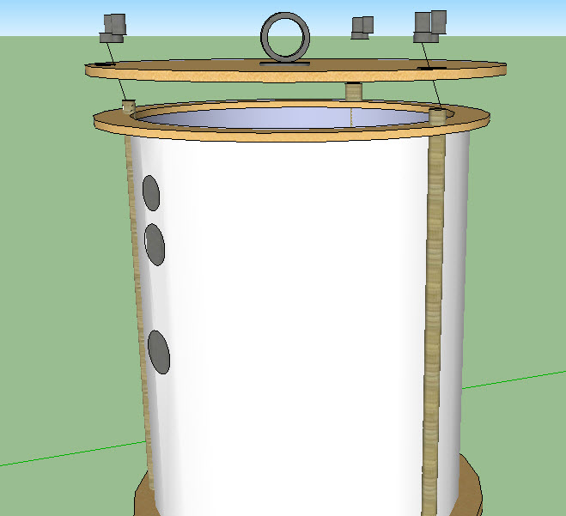
The tube for the payload itself will be 12 in long and 5 in wide. Two couplers will be on both ends of the tube to keep it in place in the rocket. Two bulkheads will also be on both ends to seal the equipment inside the payload. The couplers will be epoxied onto the tube, and the bulkheads will be secured by three metal rods. The rods ends will be threaded for a wing bolt to tighten to them. The rods will hold the top and bottom together and add support to the payload as a whole. Two I-bolts will be on the top and bottom bulkheads to connect the payload to the rocket. The I-bolt on top will be attached to the drogue chute and the other to a shock cord that goes to the rest of the rocket. Three small holes will be on the side of the body tube to give the exposure the sensors need to record accurate data. The payload will be deployed at apogee and will fall with a drogue chute attached to it and the rest of the rocket.

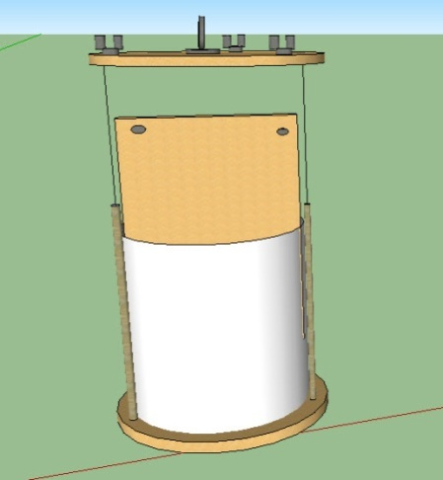
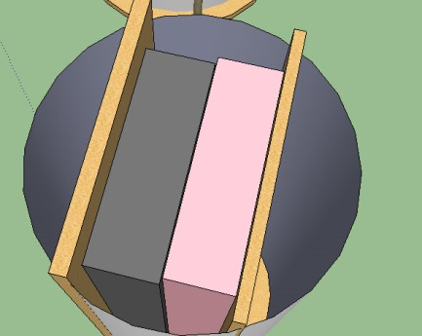
The joined wooden pieces will be inserted into the tube so that there is no room to move. Both pieces will have the same width so that the two pieces can’t move during flight.

For us being a second year team we have overall made a big improvement in the payload. There are now four different types of data taking in and three experiments that we have to annualize. We are measuring three aspects of the Earth and one of how many g’s the rocket does in flight. The physical size of the payload has grown in length and width.
Part E
The Spring Grove Area High School Rocket design for the launch vehicle is designed and intended to reach an altitude of 5,280 feet above ground level and not exceed that limit. During the flight, the vehicle is designed and made to remain under mach 1 for the entire flight going up and returning safely back to Earth. This rocket is designed to contain a recovery system and proper components to make the rocket recoverable and reusable. The rocket is also designed to only contain four independent sections all tethered together which is exactly the legal limit. The launch vehicle shall be constructed before reaching a launch site, so that the rocket is capable of being prepared for flight within two hours from the time the FAA flight waiver opens. The rocket is going to contain the proper components needed to keep the rocket in launch-ready configuration for one hour without losing any of functionality of any onboard components that are critical to the safety and success of the launch. The launch vehicle shall also contain components which would make it compatible with either an eight foot 1010 or a 1515 rail. The vehicle will also be capable of being launch with a standard 12 volt DC current firing system. It won’t need external circuitry or special ground support equipment to initiate its launch. The vehicle will make use of a commercially available solid fuel motor propulsion system which uses an ammonium perchlorate composite propellant approved by the NAR, TRA, and the CAR. The vehicle shall contain no more ballast than 10% of the unballasted vehicle mass. The final rocket design will be flown and recovered in full scale prior to the FRR. The successful flight of the full-scale rocket shall be documented on the flight certification form by a Level 2 or 3 NAR/TRA observer, and then document in the FRR. After successful completion of the full-scale flight, the rocket and its components will not be altered without the concurrence of the NASA Range Safety Officer (RSO). All of our launch vehicles won’t, in any way employ forward canards, forward firing motors, titanium sponges, hybrid motors, or a cluster of motors.

The launch vehicle of Spring Grove Area High School has been designed to deploy two separate recovery systems. The first of those two recovery systems is designed to deploy at apogee and consists of a small, drogue parachute. The secondary recovery system, that deploys at a much lower altitude consist of a larger, main chute. This deployment is necessary to reduce the speed of the falling rocket to a safer landing speed. All sections of the vehicle shall have a kinetic energy less than 75 foot pounds of force. The vehicle has also been designed to land within 2500feet of the launch pad, assuming a 15 miles per hour wind, ensuring the safety of those outside of the 2500foot radius of the launch pad. The recovery system circuits have also been designed to be completely separate from the payload’s electrical circuits. The recovery system of the rocket has also been designed to include commercially available altimeters. The altimeter contained within the recovery system has also been designed by the manufacture to be armed from the outside of the rocket airframe with an arming switch. The altimeter shall have a power supply reserved for the use of the altimeter only. The arming switch for the altimeter will also be capable of being locked in the ON position for the entire duration of the launch. The arming switch for the altimeter must be less than six feet above the base of the rocket. The main parachute compartment and the drogue parachute compartment shall also contain removable shear pins. During flight a functional electronic transmitting device is intended to be placed inside the rocket. It will be used to track all of the components of the rocket. The recovery system electronics have also been incorporated into the rocket design in a way that no other onboard electronic devices adversely affect the recovery system. The recovery system will use low-current, commercially available electric matches to ignite all onboard ejection charges. The electronic ignition system for ejection charges won’tuse a flashbulb. In addition, a rear ejection parachute design will not be used.

Part F

Technical Challenge | Solution
The recovery system electronics interfering with the payload electronics. | The payload will be designed so that it won’t emit radio or magnetic waves. This will prevent the recovery system from failing. The payload will be separated from the recovery system so that it will not cause inadvertent failure or excitation of the recovery system electronics.
Creating a rocket that won’t go over 5280 feet. | Design the rocket to fly one mile high or slightly over under perfect conditions. This is accounted for due to the highly probable case that the rocket will weigh 25 percent more than calculated values. Therefore in experimental launches you will have factors, such as air resistance, that will cause drag.
Designing a rocket that can house a payload and chutes that won’t get stuck or tangled during deployment | Design the rocket so that the ejection charges effectively deploy the parachutes and also the payload. Place them in the correct order, or place, in the rocket so that they are successfully deployed.
Designing a protection system for the mass weight. | We will perform many stress tests on the case we are using inside the rocket and perfect the design. The team will also make sure to pack the weight correctly so that it has no tendency to fall off during flight.
Designing an external access to switch connected to the altimeter to ignite the ejection charges | Consult a Level 2 or Level 3 NAR/TRA representativeon the procedure needed for the particular ejection system that was chosen. We should have safe access to the switch on the altimeter that ignites the ejection charges. It shouldn’t affect the recovery system or the flight of the rocket.

Educational Engagement
In order to spread awareness of all science programs at Spring Grove, we first plan to hold presentations to both our intermediate and middle schools from grades 5 to 9 to inform them of our project, the basics of a rocket, and how to get involved in them when they reach the high school. If we presented to both schools, approximately over 1,000 children would be involved. Another idea is to make kits of small rockets, where upon, we would hold a workshop. Our sponsor, AquaPhoenix, would be willing to donate kits to us for the workshops. Every team member of the SLI team would lead a small group, where the member will guide the group through the basics of rocket-building. Then, all the groups would launch their small rockets, further spreading rocketry awareness. Also, a Team America Rocketry Challenge team will be created in the middle school, spreading more awareness within the middle school. Along with this we will contact local television stations and newspapers, who will make short segments on our project, further spreading awareness.
To obtain feedback, we will give small surveys to all children who were involved in our presentations or workshops. These surveys will ask how well the presentation was given, how interested the student is in joining a rocket club, and if they are interested in joining our rocketry workshop.

Project Plan
1. Timeline and Team Schedule
As far as gatherings go, there will be two types: meetings and sessions. The meetings will be discussions conducted by the Team Captain and Co-Captain with the entire team, including advisor supervision and comments from them. Sessions will only be for team members to allow them to work without advisor help as a team, though an advisor will supervise them. The schedule will include both general and formal meetings, briefings, group sessions, bonding sessions, work sessions, and construction sessions.

Meetings
At general meetings, tasks will be assigned and when they need to be completed. These meetings will be informal and short, and will be held prior to the work that is going to be done that day.
Formal meetings will have a formal agenda to discuss everything that needs to be done. This can include progress on certain tasks or problems that have come up throughout the course of the week. Team members and advisors can share their thoughts and discuss them as a team. Team members and advisors can also ask any general questions about the project and discuss them during these formal meetings.
Briefings will be informative meetings consisting of a collective report of all work that has been completed and progress on any unfinished tasks. These will be used to inform the team of any changes to the project’s budget, schedule, fundraising, and other changes rather than focusing on what needs to be done.

Sessions
Sessions will be somewhat of a counseling type of meeting. These will be used to address personal problems and challenges that have come up during the completion of the project. Team members may share personal problems that are outside of the project that are affecting their ability to work well, or explain problems that are preventing them from attending meetings. Other team members can then help in completing their part of the project. Since these are only held amongst team members, they can discuss how they feel about something else another team member has done, or if something another has done has upset them in some way in order to resolve the issue. As previously stated, these sessions can be somewhat compared to counseling sessions. They will allow team members to get help in solving personal affairs and dealing with problems within or outside of the project to relieve as much stress as possible. These will help the team understand what is going on with other team members and grow together and help each other. These sessions will be more serious than others, and are largely going to influence the project as we need everyone to be working at their best and cooperatively. Not having this will make the project more stressful not only for those directly having problems, but for the entire team as well.
As part of our effort to make our team grow together and cooperate well, special bonding sessions will be held to improve the bond between team members and advisors. These are designated to helping build relationships outside of the project. We will do various activities such as watching movies about rocketry and aerospace, and other group favorite movies that we can all watch together. As stated earlier, we need to have a friendly atmosphere in our team, and these sessions and activities are crucial to that kind of team development and maintaining a pleasurable experience for all involved.
Work sessions will be used for working on any of the reports needed throughout the project. This will present the opportunity for team members to ask others questions about their part and get clarification if needed. This will also be used as somewhat of a progress check to see what needs to be done and what has already been done. It will also give the chance for the team to work together and assist as needed.
Construction sessions will be used later in the project to actually build the rocket. Team members will be paired up with another to work on building specific parts of the rocket or payload. This will prevent mistakes and accidents from happening. If something were to happen, a partner will be right there to readily help. Construction will also have adult supervision, so partners can inform them immediately if something were to require attention or assistance. Both team members must read any safety rules associated with tools before operating them for their own safety and their partner’s. This will also allow for teamwork between members during construction.
Meeting Times, Session Times and Proposed Schedule
Meetings and sessions will be held on several different dates. General meetings will be held every day the team is capable of meeting and work together, typically before work sessions. Formal meetings will be mandatory meetings that will ideally be held every Wednesday from 3:00 p.m. to 5:00 p.m. Briefings will also be mandatory meetings that will ideally be held every Monday from 3:30 p.m. to 4:30 p.m. Group sessions will be held every other week on Thursday. Bonding sessions will be held at least once a month with the date depending on when everyone on the team is capable of making the session. They will be held to celebrate any successfully completed work, special events, milestones in the project, or outstanding accomplishments. Work sessions will be during any of the available times after school. Construction sessions, once that point has been reached, will be held once or twice a week on Tuesdays or Wednesdays. Extra days will be assigned as needed to make sure we stay on schedule. Partners must also be present during construction sessions for a team member to be able to do any work on their designated task. These construction sessions will also be under close supervision by an adult so that if anything happens someone will be there to attend to the problem or injury.

2. Budget Plan
- Predicted spendings for our SLI program this year are based on our project from last year. We project to spend approximately $6,000.00 on our rocket. We bought power tools during last year's program, which will be used this year as well. We also plan to spend about $8,500.00 for the trip to Huntsville, which includes food, lodging, and gas. Unused rocket building kits from last year will be used in this year's educational engagement, so we don't plan on spending on educational engagement

3. Funding
- The Spring Grove SLI intends to raise funds from sponsorships, grants and donations. The SLI team will seek sponsorship for our involvement in engineering and STEM projects from local businesses that chose to sponsor our SLI team last year and from many new business sponsorships opportunities in the area. Our primary sponsor from last year, AquaPhoenix, is willing to sponsor us again for this year's project. All businesses that choose to sponsor us will be placed on our final rocket, team shirts and acknowledged on our SLI school website. We will be raising additional funds though school projects and community events, such as football games. The team will also be receiving money through the grants offered by NASA for acceptance of our proposal and for our placement at TARC nationals. We plan on applying for many more additional grants to fund our project. We plan on submitting an application to Lowe's Toolbox For Education Grant, which offers up to $5,000 in grants. We will also accept monetary, material or service donations.

4. Community Support
- To publicize our project our team will make contact with local television stations and newspapers that were willing to show case our project for us last year and see if they will do the same this year. We will also be using our own SLI website to notify the public about the project and to post updates. We plan on making presentations to both our middle school and intermediate school about our project and the clubs offered at our high school. We will talk to local radio stations to see if they were willing to make a short segment about the SLI team at the Spring Grove High School. We also intend to create posters to put around our school and local businesses to promote and encourage sponsorship and donations.
5. Major Challenges and Solutions:
- The major challenges that are most likely to accrue are either safety hazards, not raising enough money for the competition of our project, or going over the budget we have set out for our project.
- The best way to avoid safety hazards is to have team members and supervisors read the all operation manuals for the tools and products that will be handled during the completion of our project before proceeding with any of such devices or products, while following the enclosed safety plan.
- We will also address if a team member is comfortable with using a tool at any time or not.
- To raise enough funds for our project we will be holding public outreach programs for funding and support we will be contacting local businesses for grants such as our local power company’s (MetEd’s)
- Grant on projects that have to do with power and electricity based experiments.
- To stay on budget, we will keep track of all founds being used and track whether the prices of materials are within the projected coast by researching for the best pricing of the materials. If going over budget is inevitable, do to rising prices of materials, we will raise more funds from companies using our progress on the project to incite sponsorship from more companies and businesses.

6. Plan for Sustainable Support of Rocket Project:
- In order to make it to Huntsville, we want to work with people, local businesses, and corporate sponsors in and around the Spring Grove area. We plan on spreading awareness of our rocketry programs at Spring Grove to every adult and student in the area, to accomplish this we would like to create hands-on learning experiences for kids in our community to explore and learn more about the rocketry field.
- This includes giving a presentation to inform Spring Grove Middle and Spring Grove Intermediate students about the design and engineering of rockets. We will teach as many students as possible about rocketry and aerospace as It is one of our goals in giving presentations to interest people in joining our science clubs.
- We will also be holding public out-reach and funding programs at school and local events to help with awareness of our project to get the attention of adults of our community.
- We hope to have small groups work together and build small scale rockets, Each group will have an SLI member directing the group to help teach the students to build the small rocket. If feasible, we may launch the said rockets (if they are deemed safe to fly). We want to provide fun hands on experience for our students so more students will be interested in joining TARC and potentially even SLI in the future.
- In order to spread public awareness, we are planning to contact television stations, such as FOX and our local news channels , to see if they are interested in making a short segment on the SLI program of Spring Grove High School. We will also contact local radio stations such as 107.7 and 105.7 to see if they are interested in speaking on behalf of our program here at Spring Grove.

