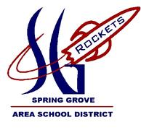
NIGHT

The Spring Grove Science Department and the Rocketry Team are hosting a STEM Night on April 20th, from 6-8 pm at the High School!

Air Cannon Demos
Rocket Building:
Small Rocket- $10
Medium Rocket- $15
Large Rocket- $20

Rocket Coloring
Physics Labs
Rocket Building

Chemistry Labs
Straw rockets
And More!!

Meet the rockets – See the largest rockets the team has built and flown
STEM Night Registration Full payment is required at time of registration.
Child’s name: Phone #:
Parent’s name: Alternate Phone #
Email:
(Please make a copy for other registrants- one per person, please)
FEE Enclosed: make checks payable to SGASD; Mail to: STEM Night, c/o SGASD, 1490 Roths Church Road, Spring Grove, PA 17362.
You can also pay online via PayPal. Go to www.springgroverocketry.weebly.com and pay online using our Paypal link (Just click on blue button to the right that says “Support our Rocket Scientists now”).

No fee to attend, only for rocket building sessions and concession area.

